
Module Code | : | CT111-3-2-COMT – Computing Theory
Intake Code | : | APD2F2509CS(CYB)
Lecturer Name | : | Ms. FARHANA ILLIANI BINTI HASSAN
Hand out Date | : | Monday, 6th April 2026, Week 7
Hand in Date | : | Sunday, 31st May 2026, Week 13
Group No. | : | Group 8
Group Leader | : | AHMED MIRAHUSAIN ALVI

Student ID | Student Name
TP084807 | AHMED MIRAHUSAIN ALVI
TP085327 | SULTAN ABDULLA OMAR TAKRORI
TP082459 | MOHAMED ABDIFATAH ALI
TP085061 | MUHAMMAD TAIMOOR JAMAL

WORKLOAD MATRIX
NAME (TP) | TASKS | SIGNATURE
AHMED MIRAHUSAIN ALVI (TP084807) | - Chapter 1 (Formal Problem Definition, Input Alphabet $Σ$, and Set-Builder Language Characterization).  - Chapter 4 (GNFA Optimization, Intermediate State Elimination, and Final Closed-Form Regular Expression Reduction). | ALVI
SULTAN ABDULLA OMAR TAKRORI (TP085327) | - Chapter 2 (NFA Architectural Design, State Graph Modeling, and Design Paradigm Selection Justification).  - Chapter 5 (Algorithmic Automata Complexity Analysis, O(n) Best-Case & Worst-Case Execution Characterization). | STK
MOHAMED ABDIFATAH ALI (TP082459) | - Chapter 3 (Formal Quintuple Notation, Complete State Transition Table $δ$Construction)  - Chapter 3 (Step-by-Step Valid String Computation Tracing for arite and Rejection Failure Tracing for ase). | 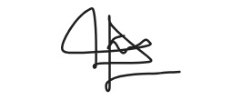
MUHAMMAD TAIMOOR JAMAL (TP085061) | - Chapter 6 (Theoretical Proof of Language Decidability and Finite-State Boundary Assessments).  - Chapter 6 (Higher-Order Computational Analysis: Pushdown Automaton Stack Modeling & Turing Machine Architecture). | 

TABLE OF CONTENTS

PART A: AUTOMATA & REGULAR EXPRESSION 1
CHAPTER 1: FORMAL PROBLEM DEFINITION 1
1.1 Specification of the Input Alphabet ($Σ$) 1
1.2 Real-World Functional Descriptions of System Symbols 1
1.3 Set-Builder Notation of the Accepted Language (L) 2
CHAPTER 2: FINITE AUTOMATON ARCHITECTURAL DESIGN 4
2.1 Nondeterministic Finite Automaton (NFA) State Graph Diagram 4
2.2 Comprehensive State-by-State Structural Explanation 5
2.3 Design Paradigm Justification: NFA vs. DFA Selection Rationales 6
CHAPTER 3: MATHEMATICAL TUPLE ELEMENTS & EXECUTION TRACKING 7
3.1 Formal Definition Quintuple Notation $(Σ,S, F, q, δ)$ 7
3.2 Complete Set State Transition Table ($δ$) 7
3.3 Valid Input Stream Validation: Step-by-Step String Computation Trace 8
3.4 Exceptional Input Stream Evaluation: Step-by-Step Rejection Failure Trace 9
CHAPTER 4: REGULAR EXPRESSION ALGEBRAIC GENERATION 10
PART B: COMPLEXITY & COMPUTABILITY 14
CHAPTER 5: ALGORITHMIC AUTOMATA COMPLEXITY ANALYSIS 14
5.1 Best-Case Time Complexity Characterization (O(n) Evaluation) 14
5.2 Worst-Case Time Complexity Characterization 15
CHAPTER 6: LANGUAGE DECIDABILITY & COMPUTABILITY PROOFS 16
6.1 Theoretical Proof of Language Decidability for Language L 16
6.2 Boundary Assessment of Finite-State Computational Frameworks 17
6.3 Real-World Limitations: Architectural Aspects Beyond Finite Automata Capabilities 17
6.4 Higher-Order Computational Analysis: Pushdown Automaton (PDA) and Turing Machine (TM) Modeling Requirements 18
6.4.1 Pushdown Automaton (PDA) for Queue Counting 18
6.4.2 Turing Machine (TM) for Database and Balance Management 18
REFERENCES 19

PART A: AUTOMATA & REGULAR EXPRESSION

CHAPTER 1: FORMAL PROBLEM DEFINITION
This chapter establishes the real-world operational inputs and language conditions for the MyTol Highway Smart Toll System.

1.1 Specification of the Input Alphabet ($Σ$)
The input alphabet consists of all the physical actions, sensor detections, database results, timeouts, and manual commands that can happen at the toll lane:
$$Σ=\left\{ a,r,n,s,i,t,f,e,c\right\}$$

1.2 Real-World Functional Descriptions of System Symbols
Every symbol in the alphabet corresponds directly to a specific event in the toll system:
Symbol | Event Description
a | Approach: Vehicle detected by gantry sensor.
r | RFID Valid: Valid RFID tag detected.
n | No RFID: No tag detected (10s timeout reached).
s | Sufficient: Account balance is sufficient.
i | Insufficient: Account balance is insufficient.
t | Top-up: Successful top-up completed at kiosk.
f | Fail Top-up: Top-up not completed (45s timeout reached).
e | Exit: Vehicle clears the exit sensor.
c | Cancel: Operator presses the override/reset button.

1.3 Set-Builder Notation of the Accepted Language (L)
The language L is formally defined as the comprehensive set of all event sequences that represent a completed, successful transaction where the toll is fully processed, and the vehicle departs from the lane. Utilizing formal set-builder notation, the language accepted by the automated system is expressed as follows:
L = {$w∈Σ$* $∣δ$*(q₀, $w$) $∈$ F}
- $w∈Σ$*: Represents an input string w consisting of a sequence of operational events drawn from the Kleene star closure of the system alphabet $Σ$.
- $δ$*(q₀, $w$): Denotes the extended transition function, which sequentially processes the entire string w from left to right, starting explicitly from the initial standby state q₀.
- $∈$ F: Establishes the membership parameter requiring the terminal state reached after execution to belong to the set of final accepting states F.

From a functional perspective, any valid sequence w within this language must initiate precisely when a vehicle is detected by the entry gantry sensor (a), advance smoothly through an authorized automated validation path, and terminate exactly when the vehicle clears the physical exit sensor (e).
Consequently, any event stream that causes a vehicle to remain stationary within the lane, exceeds designated processing timeouts, or requires manual intervention via an operator reset button (c) is strictly excluded from this language definition.
1.4 Operational Mathematical Characterization of the Acceptance Condition
For an event sequence to be accepted, processing the symbols must move the system from its initial setup to its final state. Mathematically, the extended transition function $δ$* must satisfy:
$δ$*(q₀, $w$) = {q₇}
Where q₀ is the start state and F = {q₇} is the final state reached after a vehicle successfully exits.
Case-Specific Application Examples:
Standard Smooth Run (arse): Vehicle detected by gantry sensor (a), valid RFID tag detected (r), account balance is sufficient (s), and the vehicle clears the exit sensor (e). The system ends in q₇, so the sequence is accepted.
Kiosk Top-up Run (arite): Vehicle detected by gantry sensor (a), valid RFID tag detected (r), account balance is insufficient (i), successful top-up completed at kiosk (t), and the vehicle clears the exit sensor (e). The system ends in q₇ , so the sequence is accepted.
Failed and Cancelled Runs: If no tag is detected ($a→n)$ or the top-up is not completed ($a→r→i→f)$ the system gets stuck in a fault state When the operator presses the override/reset button (c), the system goes back to the start state q₀ . Because q₀ is not a final state, sequences like anc or arifc fail the condition and are rejected. This ensures unfinished or failed automated transactions are never counted as successful transits.

CHAPTER 2: FINITE AUTOMATON ARCHITECTURAL DESIGN
This chapter provides the visual diagram and a detailed breakdown of the Nondeterministic Finite Automaton (NFA) designed for the MyTol smart toll system. It explains what each state tracks in the real system and justifies why an NFA was chosen over a DFA.

2.1 Nondeterministic Finite Automaton (NFA) State Graph Diagram
The landscape diagram below shows the entire operational flow of the gantry lane. The main successful path runs horizontally through the center spine ($q0→q1→q2→q4→q7)$, while timeouts, manual bypasses, and lockdown errors branch into the upper and lower tracks.
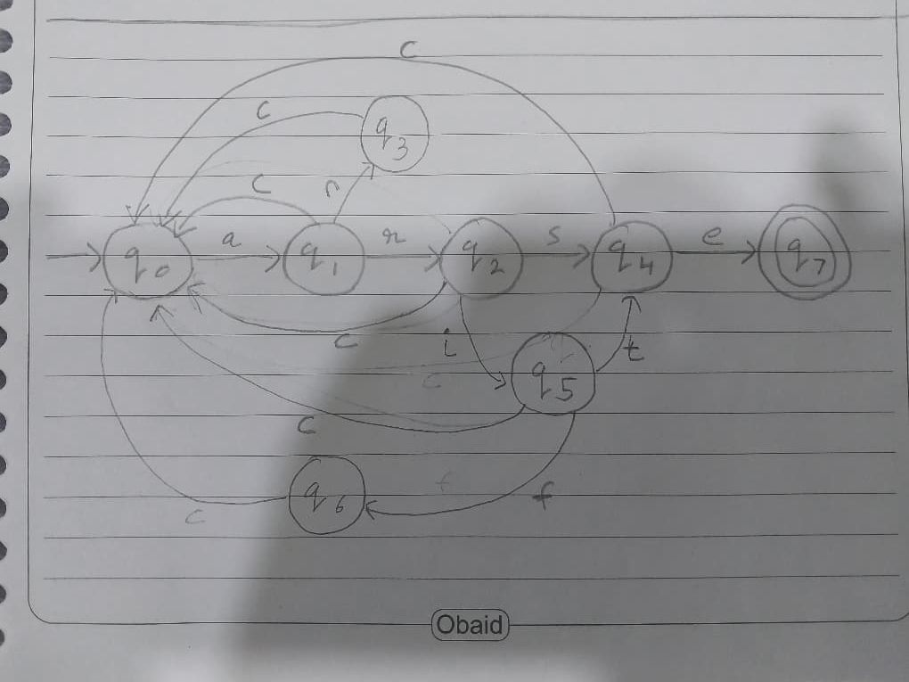

2.2 Comprehensive State-by-State Structural Explanation
The NFA utilizes eight distinct states to manage the real-world operational status of the toll lane hardware and payment validation:
q0 (Idle / Standby - Start State): The default state of the toll lane. The barrier is down, the system display is blank, and the gantry is waiting for a vehicle to trigger the entry sensor (a).
q1 (Waiting for RFID): A vehicle has been detected at the gantry sensor (a). The system activates the overhead RFID scanner and starts an internal 10-second countdown clock.
q2 (Checking Account Balance): A valid RFID tag has been detected (r) within the 10-second window. The system pauses the timer and queries the central database backend to check if the linked Touch 'n Go wallet has enough money to pay the toll.
q3 (Manual Lane Mode): The system reached the 10-second timeout limit without detecting a valid tag (n). The automated system shuts off, and the gantry switches to manual mode where a human operator takes over to process or bypass the car.
q4 (Barrier Open / Clearance): The toll amount has been successfully processed either immediately due to a sufficient account balance (s) or following a successful kiosk top-up (t). The system commands the physical gantry barrier to lift, and the lane waits for the car to pass through.
q5 (Waiting for Kiosk Top-Up): The database returned an insufficient balance flag (i). The barrier stays down, a warning message is displayed to the driver, and a 45-second countdown clock begins while the user interacts with the payment kiosk.
q6 (Alert / Lane Lockdown): The driver failed to complete their top-up within the 45-second window (f). The system triggers a critical timeout exception: an alert is raised to highway staff, warning lights flash red, and the barrier remains locked shut to stop the car from passing.
q7 (Vehicle Transited - Accepting State): The vehicle has physically driven past the gate and cleared the exit sensor (e). The barrier automatically lowers back down behind it, confirming a fully completed, successful automated transaction.

2.3 Design Paradigm Justification: NFA vs. DFA Selection Rationales
A Nondeterministic Finite Automata (NFA) was chosen as the most suitable computational model for the MyTol system over a Deterministic Finite Automaton (DFA) due to two major system constraints:
1. Eliminating Clutter from the Global Cancel Rule
Requirement (g) states that the operator's cancel/override button (c) can reset the system to idle from any point in the process. In a strict DFA, every single state would be forced to explicitly handle all 9 symbols in the alphabet $Σ$. This would mean drawing dozens of extra "trap arrows" for physically impossible combinations such as an exit sensor trigger occurring before a car even approaches.
By utilizing NFA design rules, we only draw transitions for paths that actually exist in the case study. If an unmapped event occurs, the NFA path simply terminates naturally. This keeps our diagram readable and directly reflective of the toll system's operational instructions without masking the core logic in visual noise.
2. Streamlining the Regular Expression Conversion
Our assignment requires us to formally generate a Regular Expression from our state machine. If we used a fully complete DFA with an explicit trap state and error loops, our State Elimination Method would require a massive amount of tedious algebraic reductions.
Choosing an NFA lets us build a highly streamlined model where dead-end branches like the manual mode (q3) or the lockdown state (q6) collapse cleanly back into (q0) using the operator button (c). This creates a direct parallel structure that allows us to find the final regular expression with significantly fewer algebraic steps, preventing manual calculation errors.

CHAPTER 3: MATHEMATICAL TUPLE ELEMENTS & EXECUTION TRACKING

3.1 Formal Definition Quintuple Notation $(\left\langle Σ,S, F, q, δ\right\rangle )$
The 5 quintuple information elements for the MyTol smart toll gantry NFA are defined as follows:
- $Σ=\{a,r,n,s,i,t,f,e,c\}$
- S = { q0 }
- F = { q7 }
- q = { q0, q1, q2, q3, q4, q5, q6, q7 }
- $δ /$state transition table

3.2 Complete Set State Transition Table ($δ$)
State | Approach (a) | RFID Valid (r) | No RFID (n) | Sufficient (s) | Insufficient (i) | Top-up (t) | Fail Top-up (f) | Exit (e) | Cancel (c)
q0​ | {q1​} | ∅ | ∅ | ∅ | ∅ | ∅ | ∅ | ∅ | ∅
q1​ | ∅ | {q2​} | {q3​} | ∅ | ∅ | ∅ | ∅ | ∅ | {q0​}
q2​ | ∅ | ∅ | ∅ | {q4​} | {q5​} | ∅ | ∅ | ∅ | {q0​}
q3​ | ∅ | ∅ | ∅ | ∅ | ∅ | ∅ | ∅ | ∅ | {q0​}
q4​ | ∅ | ∅ | ∅ | ∅ | ∅ | ∅ | ∅ | {q7​} | {q0​}
q5​ | ∅ | ∅ | ∅ | ∅ | ∅ | {q4​} | {q6​} | ∅ | {q0​}
q6​ | ∅ | ∅ | ∅ | ∅ | ∅ | ∅ | ∅ | ∅ | {q0​}
q7​ | ∅ | ∅ | ∅ | ∅ | ∅ | ∅ | ∅ | ∅ | ∅

3.3 Valid Input Stream Validation: Step-by-Step String Computation Trace
To verify that the NFA successfully processes a valid transaction, we track a kiosk top-up run using the input string arite .
Initial Setup: The system starts at the start state q0.
Step 1 — Input symbol a: Vehicle detected by gantry sensor.
$$δ\left(q0,a\right)=\{ q1 \}$$
Step 2 — Input symbol r: Valid RFID tag detected.
$$δ\left(q1, r\right)= \{ q2 \}$$
Step 3 — Input symbol i: Account balance is insufficient.
$$δ\left(q2, i\right)=\{ q5 \}$$
Step 4 — Input symbol t: Successful top-up completed at kiosk.
$$δ\left(q5, t\right)=\{ q4 \}$$
Step 5 — Input symbol e: Vehicle clears the exit sensor.
$$δ\left(q4, e\right)=\{ q7 \}$$
Conclusion: The string processing ends exactly at state q7. Since q7 $∈F,$the string arite is successfully accepted by the model .

3.4 Exceptional Input Stream Evaluation: Step-by-Step Rejection Failure Trace
To prove that the system safely blocks and rejects an invalid sequence, we trace a scenario where a balance check is attempted out of order: ase.
Initial Setup: The system starts at the start state q0.
Step 1 — Input symbol a: Vehicle detected by gantry sensor.
$$δ\left(q0, a\right)=\{ q1 \}$$
Step 2 — Input symbol s: Account balance is sufficient. Looking at the transition table for state q1, we get:
$$δ\left(q1, s\right)= ∅$$
Conclusion: The computation stops immediately at state q1 on the symbol s because an account balance check cannot happen before a valid RFID tag is detected. Since the calculation hits an empty set ($∅$) and cannot reach the final accept state q7, and the string ase is rejected.

CHAPTER 4: REGULAR EXPRESSION ALGEBRAIC GENERATION
To systematically collapse the automaton, states are removed one by one, and their paths are combined into regular expression labels on the remaining transitions.
Step 0: The Original Diagram
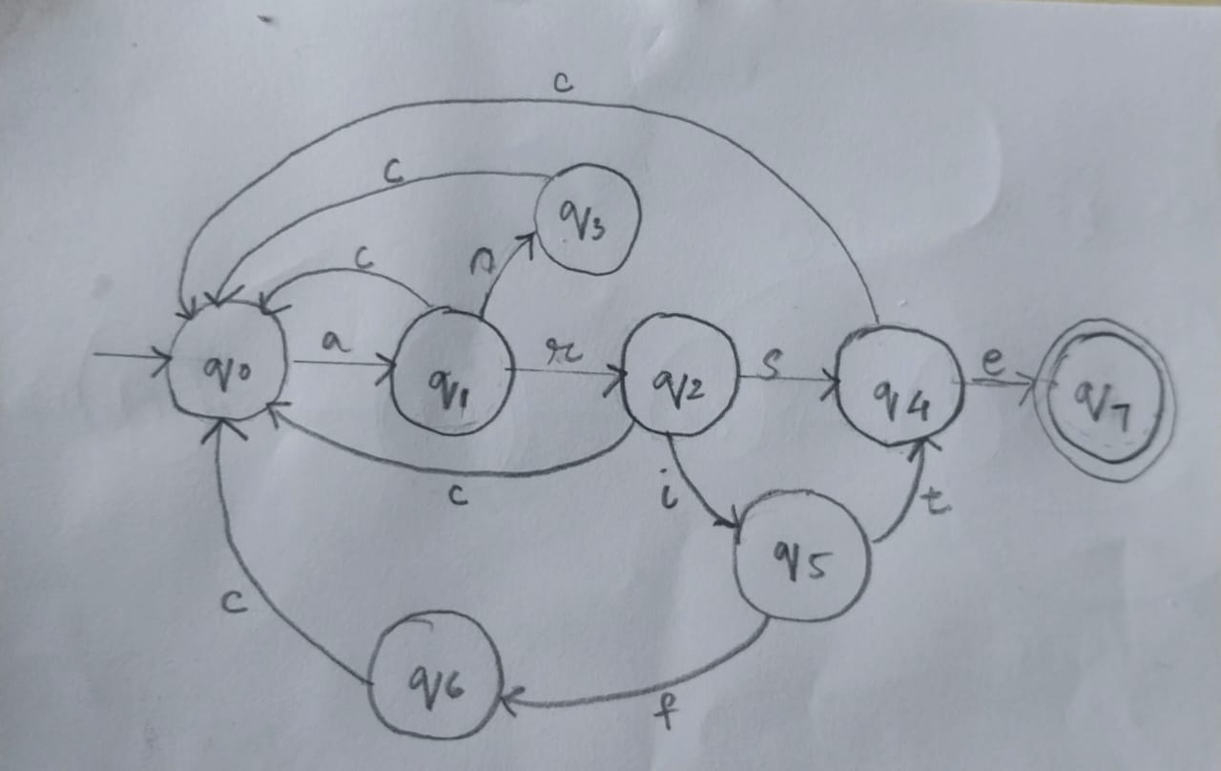
Step 1: Adding Start State and Accept Sate
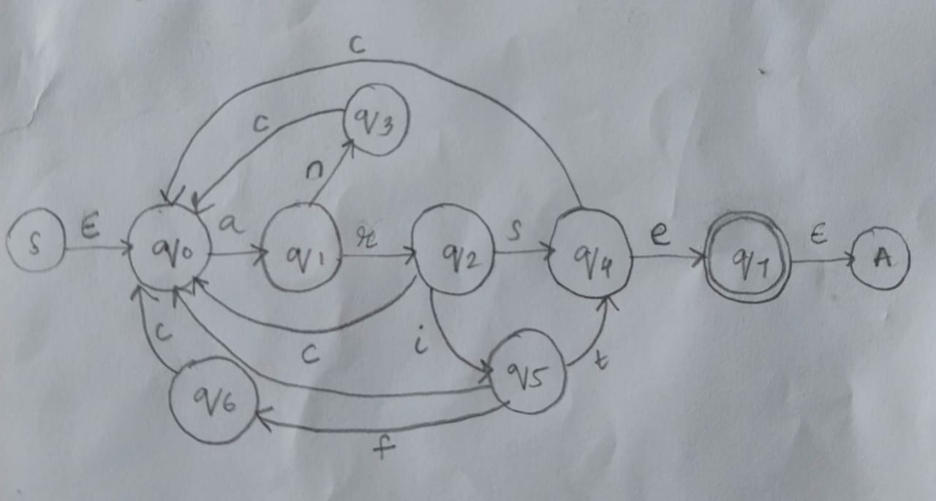

Step 2: Eliminating States q₃ and q₆
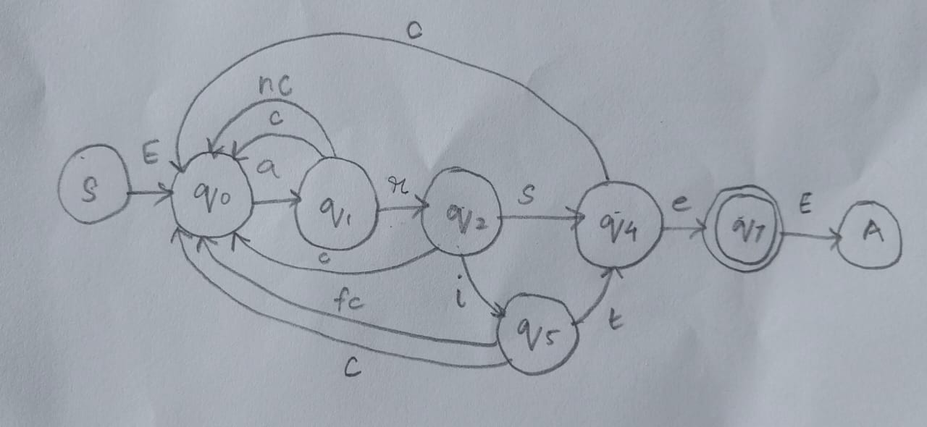
- Elimination Rule q₃: Removing q₃ creates a direct transition path from q₁ back to q₀ (nc).
- Elimination Rule q₆: Removing q₆ creates a direct transition path from q₅ back to q₀ (fc).
Step 3: Eliminating State q₁
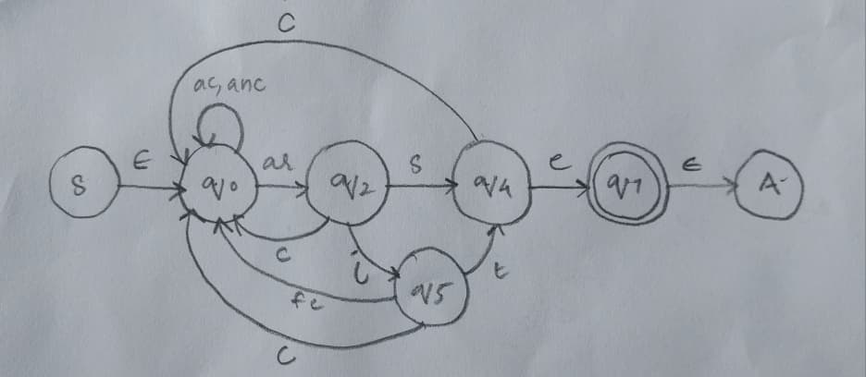
Elimination Rule: The path q₀ $→$ q₁ $→$q₂ becomes a direct line from q₀ $→$ q₂ labeled (ar).
The paths returning from q₁ back to q₀ turn into a direct self-loop on the standby state q0.
New Self-Loop on q₀: ac, anc
Step 4: Eliminating State q₅
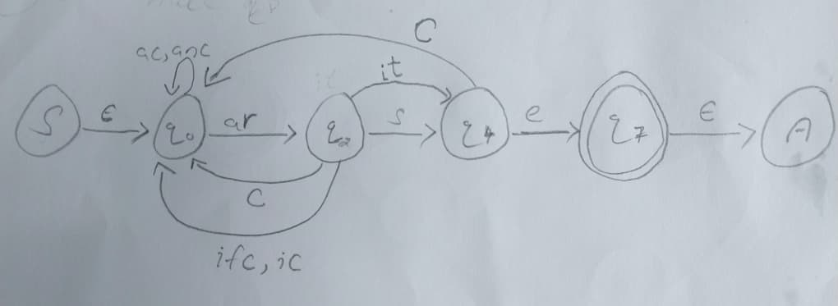
Elimination Rule:
- The path q₂ $→$ q₅ $→$ q₄ becomes a direct path from q₂ to q₄ labeled (it).
- The paths returning from q₅ back to q₀ create a direct link from q₂ back to q₀ (ifc, ic).
Step 5: Eliminating State q₂
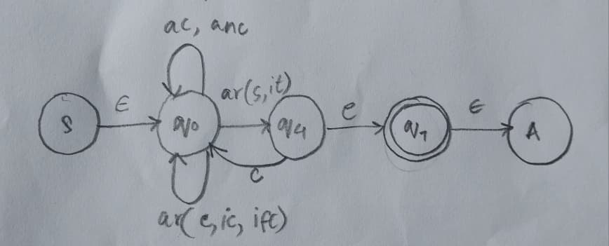
Elimination Rule:
- Combine the forward branches (s and it) into a choice grouping: (s, it). This connects q₀ directly to q₄.
- Route the incoming path (ar) through the backward branches to add a new self-loop on q_{0.}
Step 6: Eliminating State q₄
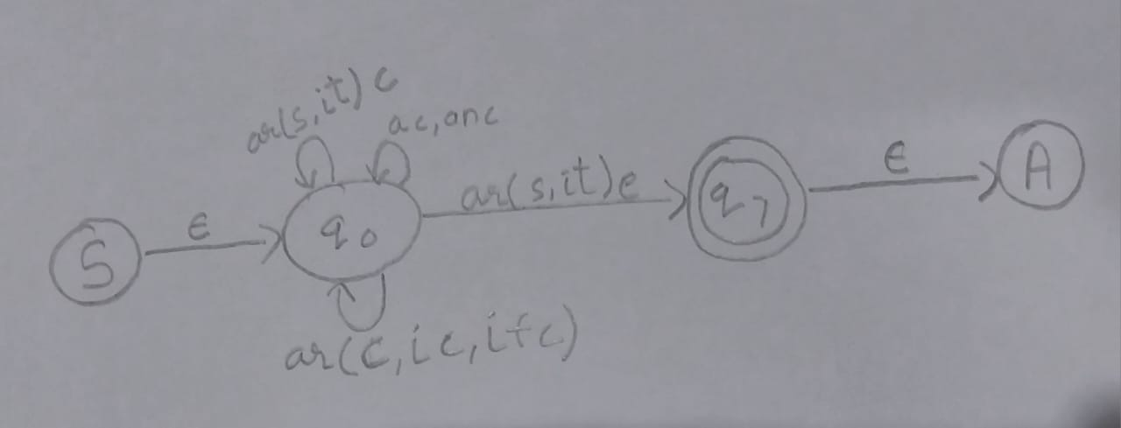
Elimination Rule:
- The forward line goes straight from q₀ $→$ q₇ labeled ( ar(s, it)e ).
- The cancel path forms the final self-loop addition on q₀ labeled ( ar(s, it)c ).
Step 7: Grouping the Self-loops on Standby State
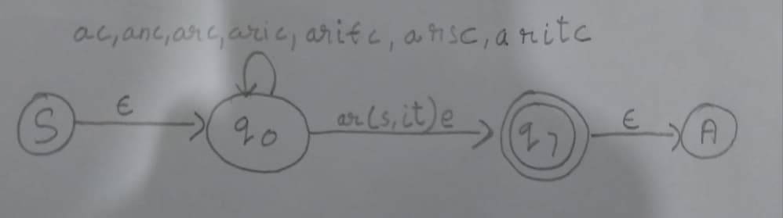
R_{loop} = ac + anc + arc + aric + arifc + arsc + aritc
We can factor out the shared vehicle approach trigger (a) to make the expression clean and readable:
R_{loop} = a(c + nc + rc + ric + rifc + rsc + ritc)
Final Regular Expression:
[a(c + nc + rc + ric + rifc + rsc + ritc)]*ar(s + it)e

PART B: COMPLEXITY & COMPUTABILITY

CHAPTER 5: ALGORITHMIC AUTOMATA COMPLEXITY ANALYSIS

5.1 Best-Case Time Complexity Characterization (O(n) Evaluation)
The best-case time complexity for the MyTol smart toll system is O(n), where n represents the total number of input symbols in the event stream. Because this automaton contains no parallel active branches or redundant path guessing, the processing time scales in a direct, one-to-one linear fashion with the length of the string.
The absolute minimum number of real-world events required to achieve a successful automated transit through the gantry lane is exactly 4 events. This occurs during a flawless transit where the account has enough money, allowing the vehicle to pass without any delays, timeouts, or operator resets.
The optimal transaction sequence is represented by the string arse (n = 4), which breaks down into the following step-by-step trace starting from the standby state:
Initial State: System sits in standby mode at q₀.
- Read symbol a: Vehicle detected by gantry sensor $→$System changes to state q₁ (1 step).
- Read symbol r: Valid RFID tag detected $→$System changes to state q₂ (1 step).
- Read symbol s: Account balance is sufficient q₂ $→$ System changes to state q₄ (1 step).
- Read symbol e: Vehicle clears the exit sensor $→$ System reaches final accept state q₇ (1 step).
{Total Computation Steps} = 4 (For an input length of n = 4)
Every single input symbol takes exactly 1 constant time transition step to process. The system moves instantly forward along its primary horizontal spine, proving that the best-case runtime matches O(n) execution parameters.

5.2 Worst-Case Time Complexity Characterization
The worst-case time complexity for the MyTol gantry control system remains strictly bounded at O(n).
To protect tollway revenues and maintain driver safety, the gantry logic can never make a premature decision to open or close the gate. The system is forced to evaluate every single symbol in the input stream sequentially because:
- An insufficient balance flag (i) or a timeout exception (f) changes the system state immediately.
- The system must wait to verify if a driver completes a kiosk top-up (t) or if an operator hits the manual cancel button (c).
- Skipping a single symbol would break the coordination between the physical barrier arm and the account database, leading to unsafe lane operations.
The longest possible successful transaction path occurs when a driver runs into an initial balance error but manages to recover by using the lane kiosk. This is represented by the string arite
(n = 5):
Initial State: System sits in standby mode at q₀.
- Read symbol a: Vehicle detected by gantry sensor $→$System moves to q₁.
- Read symbol r: Valid RFID tag detected $→$ System moves to q₂.
- Read symbol i: Account balance is insufficient $→$ System moves to the kiosk holding state q₅.
- Read symbol t: Successful top-up completed at kiosk $→$ System moves to open barrier state q4.
- Read symbol e: Vehicle clears the exit sensor $→$ System hits final accept state q₇.
{Total Computation Steps} = 5 (For an input length of n = 5)

Because each incoming event maps to at most one destination state in the transition table, the processing time never spirals out of control. It scales exactly with the size of the input stream, ensuring a highly reliable, predictable linear runtime performance.

CHAPTER 6: LANGUAGE DECIDABILITY & COMPUTABILITY PROOFS

6.1 Theoretical Proof of Language Decidability for Language L
The language L accepted by the MyTol smart toll gantry is mathematically decidable. In computing theory, a language is decidable if an automated system can read any input sequence of events and definitively halt with a clear "Accept" or "Reject" decision without getting stuck in an endless loop.
Case-specific Justification:
The MyTol NFA acts as a strict decider because it evaluates a finite sequence of toll lane events. For every transaction attempt, the system processes each symbol one by one and arrives at a definitive conclusion:
- If the sequence matches a successful transaction, the system lands in the final accept state q₇.
- If the sequence contains a timeout or a broken path, the system stops executing at an invalid state or resets to standby q₀.
Because the length of any vehicle event string n is finite and every step moves the system forward or forces a reset, the system can never loop infinitely or remain in an unresolved status.
Case Specific Application Examples:
Accepted String Trace (arite): The system processes the events in sequence, Vehicle detected (a), Valid RFID detected (r), Insufficient balance (i), Kiosk top-up (t), and Vehicle clears exit sensor (e). The path hits the accept state q₇ and terminates cleanly, declaring the string accepted.
Rejected String Trace (ase): The system processes a vehicle approach (a) but crashes immediately into an empty set ($∅$) when processing the out-of-order balance check symbol (s) at state q₁. The system halts computation instantly without hitting q₇, declaring the string rejected.

6.2 Boundary Assessment of Finite-State Computational Frameworks
While the NFA effectively captures the sequential step-by-step logic of the gantry lane, a finite-state model is fundamentally restricted by its lack of dynamic data storage.
Our current model can only remember which operational step the toll lane is currently executing. It acts entirely on immediate environmental triggers and has zero computational capacity to store variables, run balance equations, or track historical user information across multiple vehicle transits.

6.3 Real-World Limitations: Architectural Aspects Beyond Finite Automata Capabilities
The physical MyTol toll network contains three critical operational requirements that our NFA cannot calculate or model due to memory limitations:
Dynamic Financial Ledger Calculations: The NFA can distinguish between a sufficient (s) and insufficient (i) balance via database signals, but it cannot perform numerical subtraction. It cannot take an account balance variable (e.g., RM 40.00), subtract a toll fee (e.g., RM 2.50), and rewrite the new balance (RM 37.50) back to memory.
Unbounded Vehicle Queue Matching (Counting): If multiple cars enter the gantry lane sequentially, a finite automaton cannot count them. It cannot verify that the exact number of vehicle approaches (a) perfectly matches the exact number of vehicle exits (e) for an arbitrary queue size (the non-regular language a^{n}e^{n} ), because tracking an unrestricted number of vehicles requires infinite memory states.
RFID Cryptographic Parsing: The system only processes an abstract "Valid RFID" trigger (r). In reality, the gantry must read raw binary data blocks from the vehicle tag, cross-reference cryptographic keys, and look up text records, which requires string manipulation capabilities outside the scope of regular languages.

6.4 Higher-Order Computational Analysis: Pushdown Automaton (PDA) and Turing Machine (TM) Modeling Requirements

6.4.1 Pushdown Automaton (PDA) for Queue Counting
A Pushdown Automaton introduces a Last-In, First-Out (LIFO) stack memory structure. This model would allow the gantry system to physically count vehicles blocking the lane:
- For every vehicle approach event (a) detected by the entry loop, a token is pushed onto the stack.
- For every vehicle exit event (e) registered by the final sensor, a token is popped off the stack.
This allows the toll system to safely track exact vehicle matching (a^{n}e^{n}), ensuring the lane gate only shuts and returns to true idle once the stack is completely empty.

6.4.2 Turing Machine (TM) for Database and Balance Management
A Turing Machine provides an unrestricted, readable, and writable memory tape. A Turing Machine model is required to manage the backend core of the Touch 'n Go database system:
- Read/Write Mechanics: It can read an exact numeric account string from an RFID tag, search a variable data directory, and dynamically verify account status.
- Mathematical Operations: It can run mathematical algorithms directly on the storage tape to modify balance figures, execute kiosk top-up transactions (t), and permanently save the updated wallet records.

REFERENCES

Chathuminiwanasinghe. (2025, February 18). Deterministic vs Non-Deterministic Finite Automata (DFA vs NFA). Retrieved from Medium: https://medium.com/@chathuminiwanasinghe/deterministic-vs-non-deterministic-finite-automata-dfa-vs-nfa-5d1ea17c170a
GeeksforGeeks. (2025, July 23). Regular Expressions, Regular Grammar and Regular Languages. Retrieved from GeeksforGeeks: https://www.geeksforgeeks.org/theory-of-computation/regular-expressions-regular-grammar-and-regular-languages/
GeeksforGeeks. (2026, April 13). Generating Regular Expression from Finite Automata. Retrieved from GeeksforGeeks: https://cs.stackexchange.com/questions/11935/converting-an-nfa-to-regex-using-gnfa-algorithm
GeeksforGeeks. (2026, March 7). Introduction of Finite Automata. Retrieved from GeeksforGeeks: https://www.geeksforgeeks.org/theory-of-computation/introduction-of-finite-automata/
O’Regan, G. (2023, May 5). Computability and Decidability. Retrieved from Springer Nature Link: https://link.springer.com/chapter/10.1007/978-3-031-26212-8_14
Park, J. (2017, October 8). An Introduction to Complexity Theory. Retrieved from Medium: https://medium.com/@junp01/an-introduction-to-complexity-theory-3c20695725f8
Stanford Encyclopedia of Philosophy. (2025, May 21). Turing Machines. Retrieved from Stanford Encyclopedia of Philosophy: https://plato.stanford.edu/entries/turing-machine/

